

Department of Computer Science
Software Engineering

Phase 3

User Manual Document

InnovaCode

Name and ID:

Alia Khamis U19102199

Amna Rashed Almazrouei U23103547

Asma Al-Ali U22100601

Hasna Imad U23100997

Hind Almarzooqi U21201139

Namah Sultan U22100470
Reyam Sahib U23105903

Graphical User Interface (GUI)
The Shared Farm app has a clean and friendly design. It makes it easy for users to look at groceries, join events, talk to the AI assistant, and manage their orders. The app uses clear cards, big buttons, and simple layouts so people can move around the app without confusion.
There is only one main user role (Customer), but the app includes many helpful screens, such as the product catalog, AI chat, order tracking, subscription settings, and support tickets.
The next section explains each screen in the app in a simple way.

Splash_screen
A simple green welcome screen appears when the app opens. It shows the “Shared Farm” name in the center and a “Get Started” button at the bottom. This is the first screen users see when they launch the app.
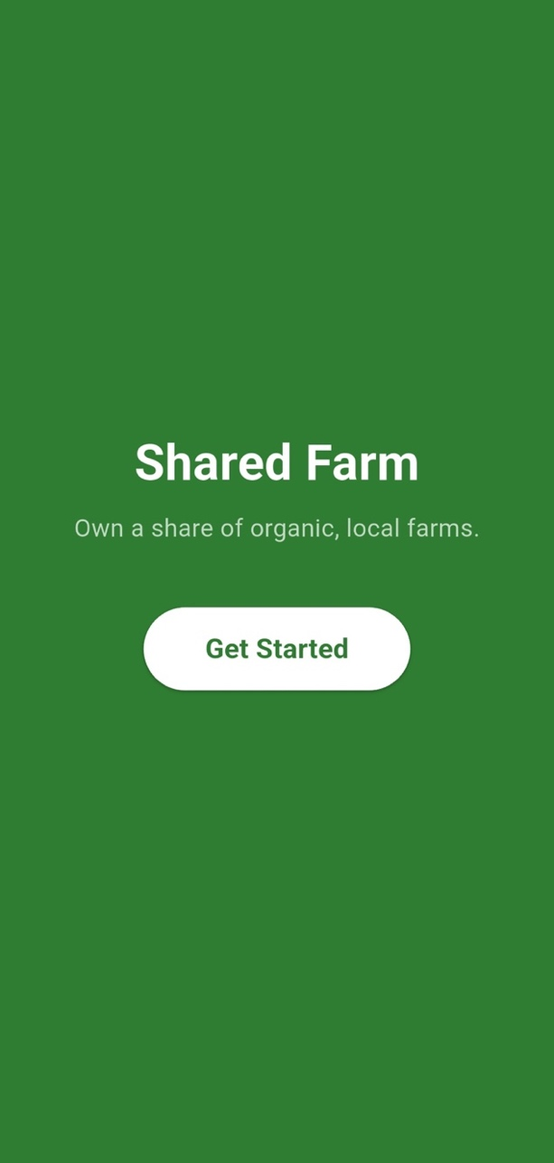

Landing_page
This screen shows the public welcome page. It includes the “Shared Farm” logo, a large farm banner image, and two main options: Sign Up or Login. It also gives a quick introduction to the app and highlights key features like farm ownership, fresh produce, and community benefits.
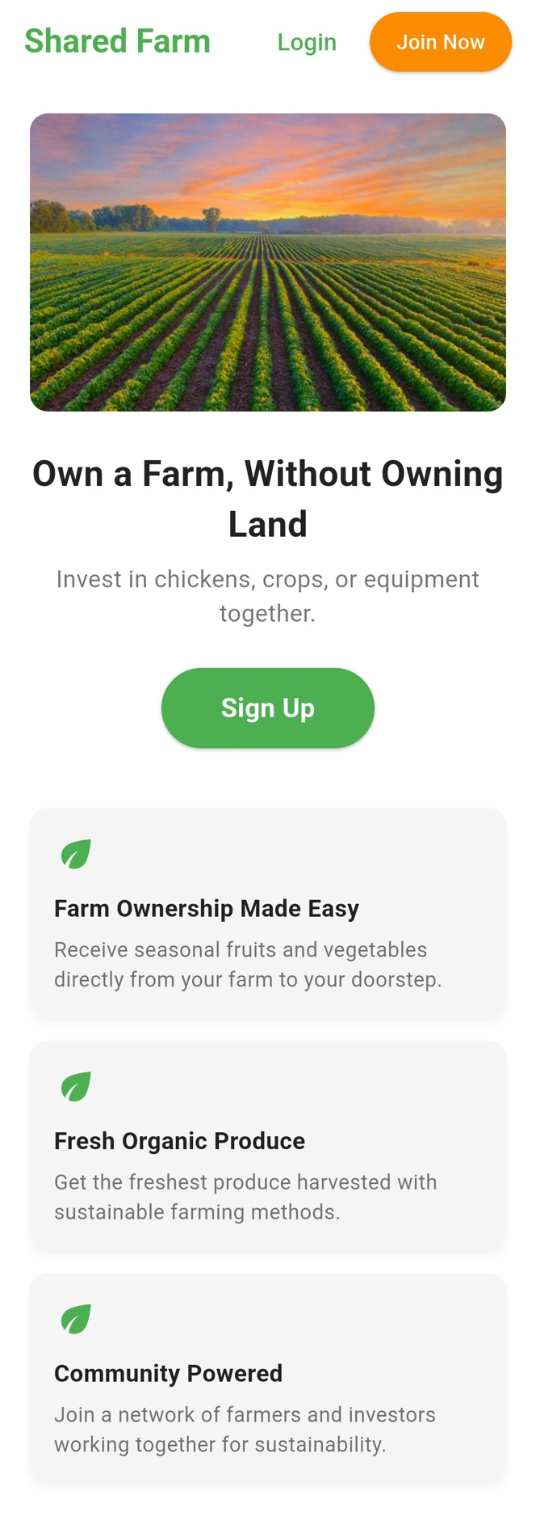

Signup_page
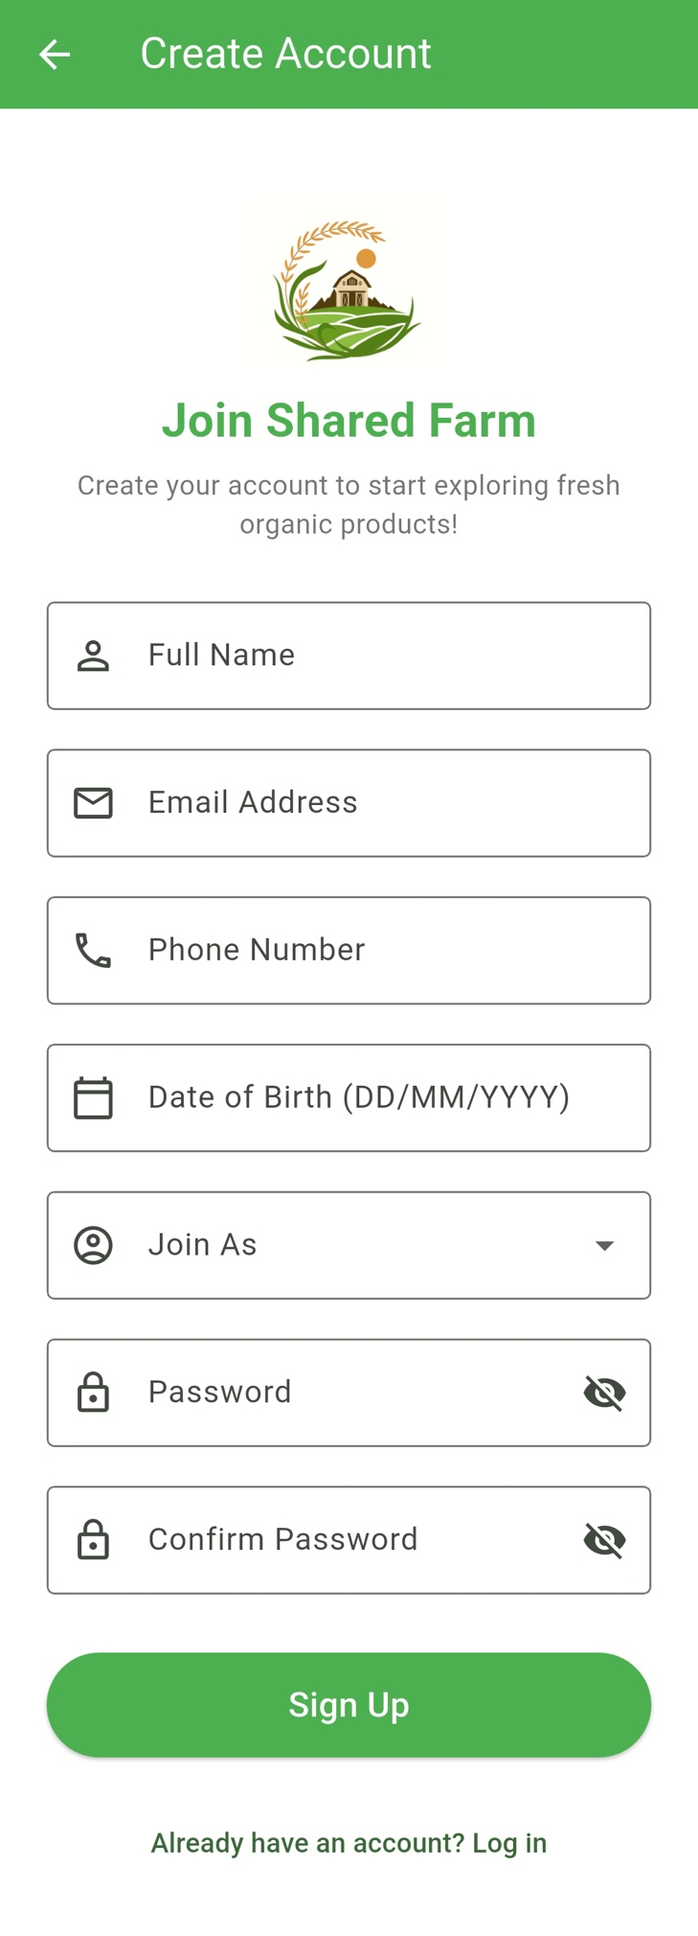
This is the registration screen where new users can create an account by entering the required personal details. It helps users sign up and get started with the app.

Login_page
This is the login screen where users enter their email and password to access their account..
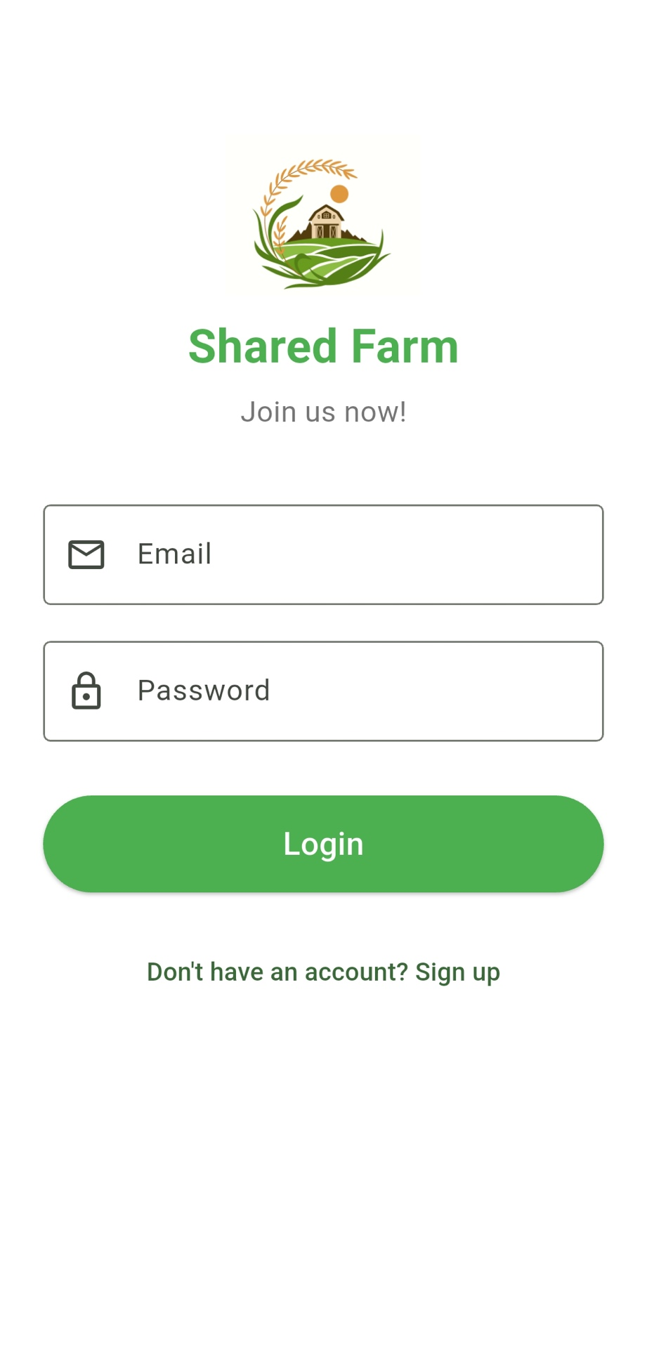

Home_screen
This is the main dashboard of the app. It shows featured items, quick category shortcuts, and easy access to key services like the cart, community events, and the AI assistant.
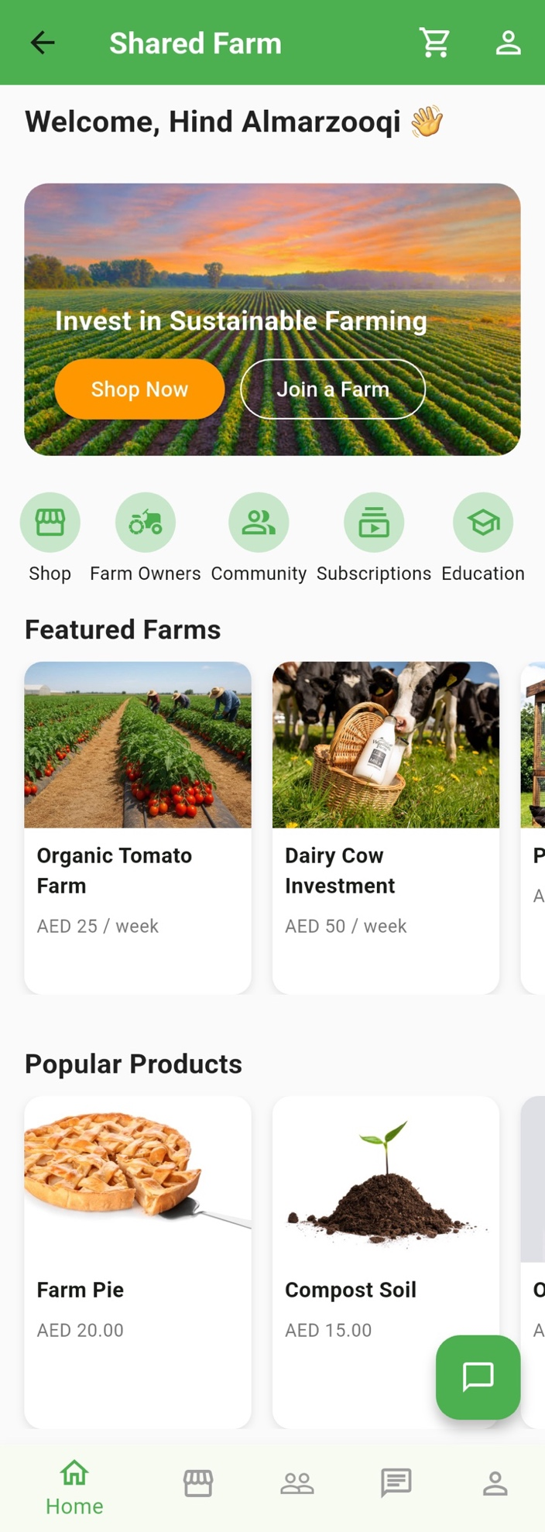

Product_catalog_page
This screen shows a grid or list of all products for sale, such as fruits, vegetables, and other farm goods. Users can open each item to see more details or add it directly to their cart.
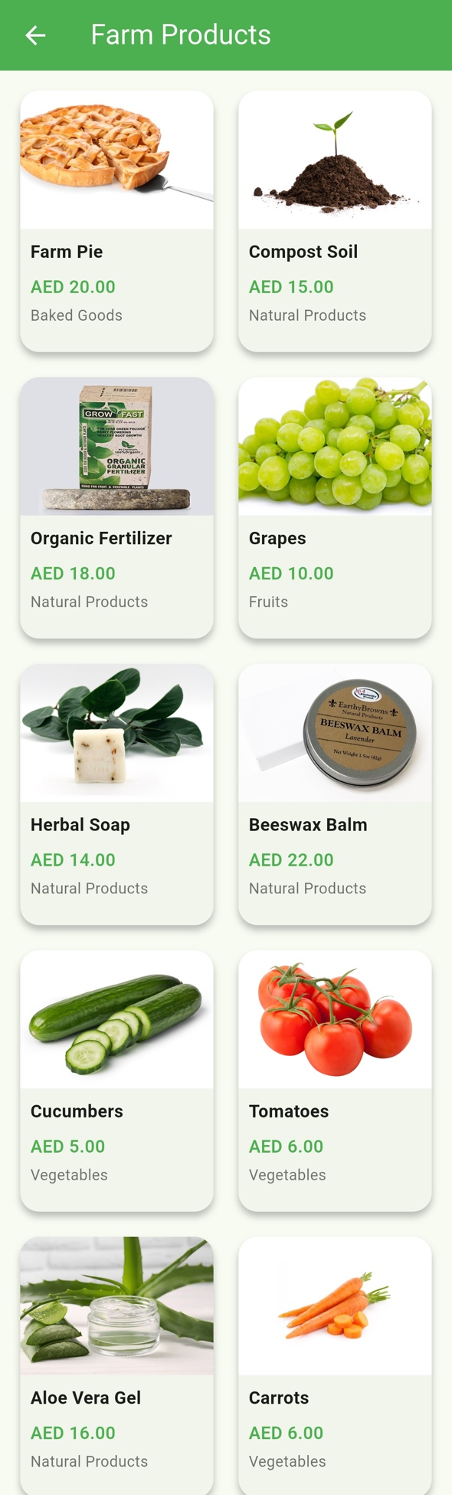

product_details_page
This screen shows the full details of one product. It includes the product image, a short description, and an “Add to Cart” button.
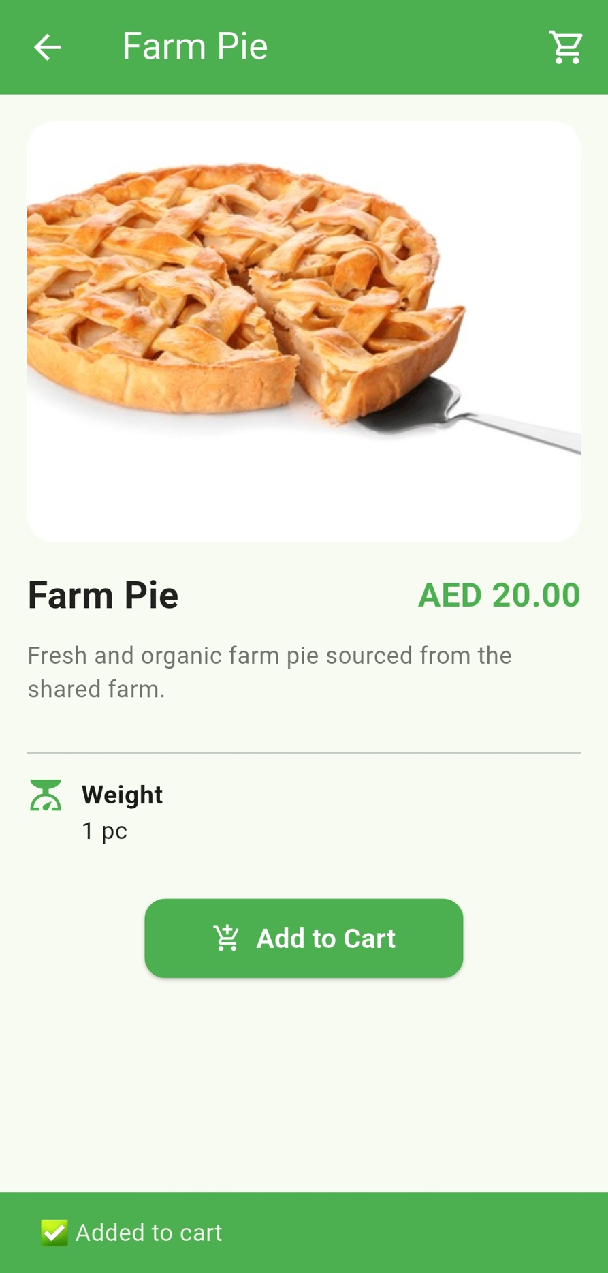

Cart_page
This screen shows all the items the user has added to their cart. They can change the quantity, remove items, or continue to the checkout.

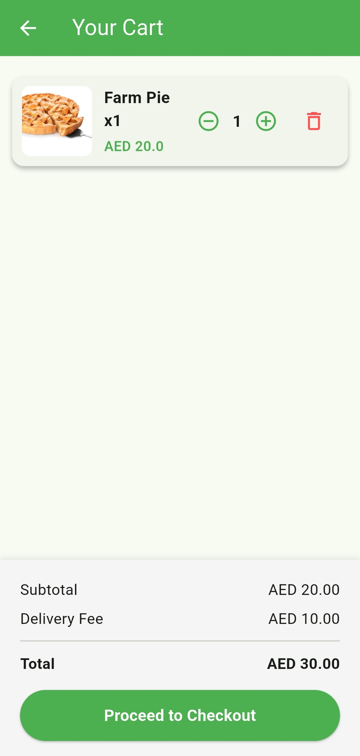

Combined_checkout_page
This is the full checkout screen. It shows the order summary with the product image, price, and quantity.
Users can review their delivery details and location, choose a payment method (Credit/Debit or Cash on Delivery), and see the subtotal, delivery fee, and total.
A “Pay AED …” button appears at the bottom to complete the order.

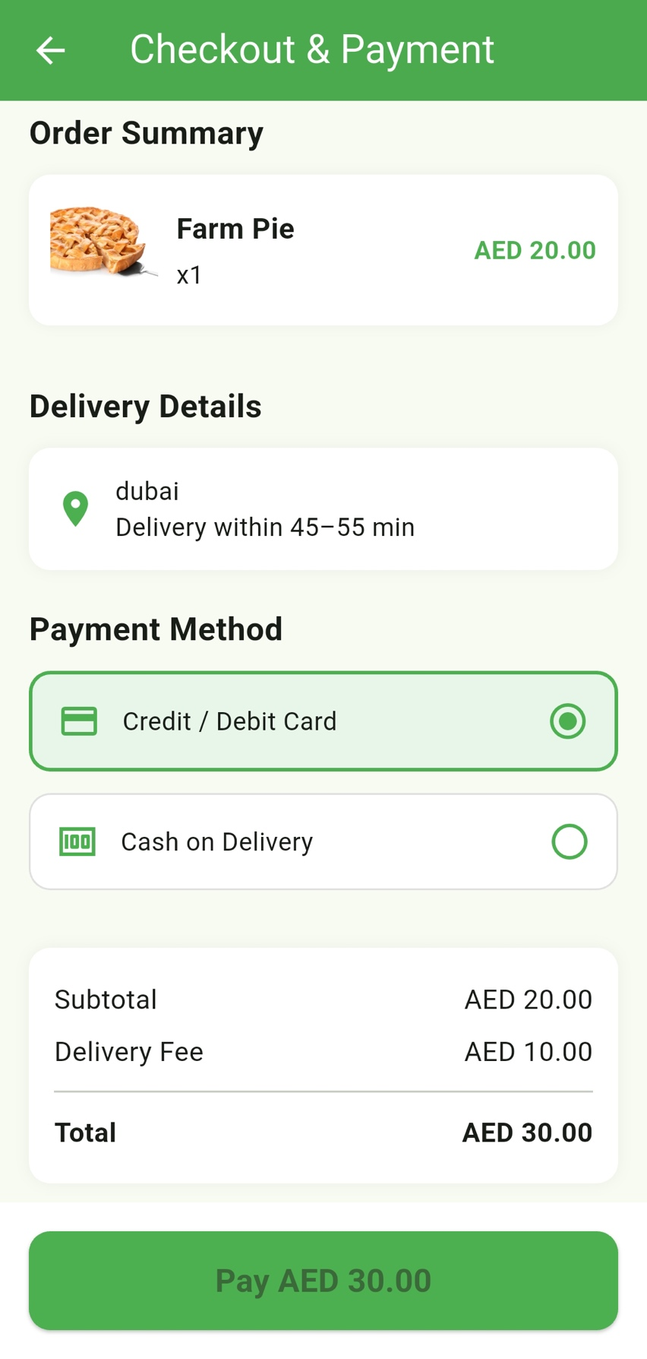

Track_order_page
This screen lets users track their order. It shows a map with the delivery route and a message saying, “Your package is on the way!” The status updates move from Packed → Sent → On Route. It also shows the driver’s name, the delivery address, and a “Back to Home” button.
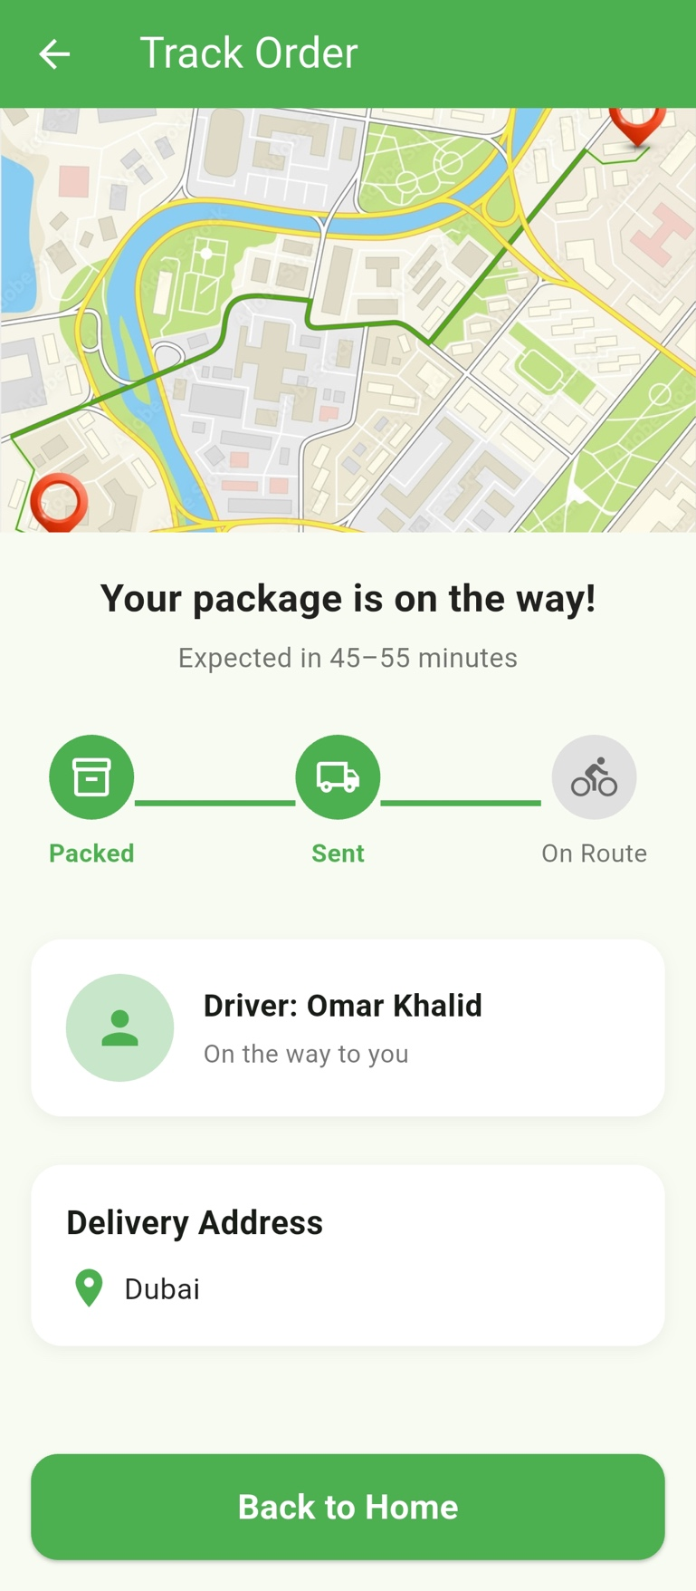

Profile_page

This screen shows the user’s profile. It includes the user’s name and role (like Customer), along with any upcoming events they joined. It also has buttons for My Orders, My Tickets, My Subscription Plan, and Edit Profile, plus a Logout button.
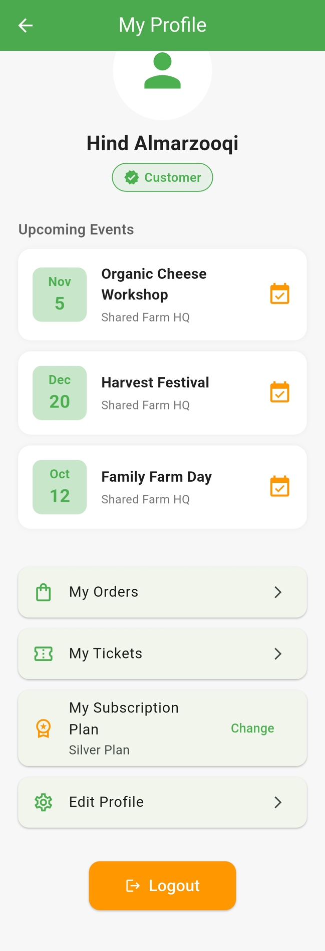

Edit_profile_page
This screen lets the user update their personal information, such as their name, email, and other basic details.

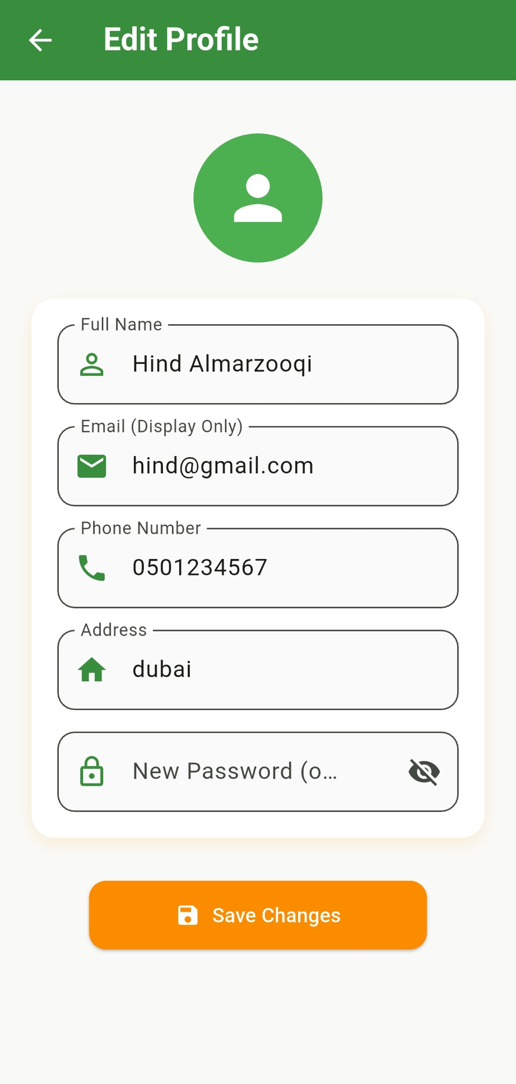

Subscription_page
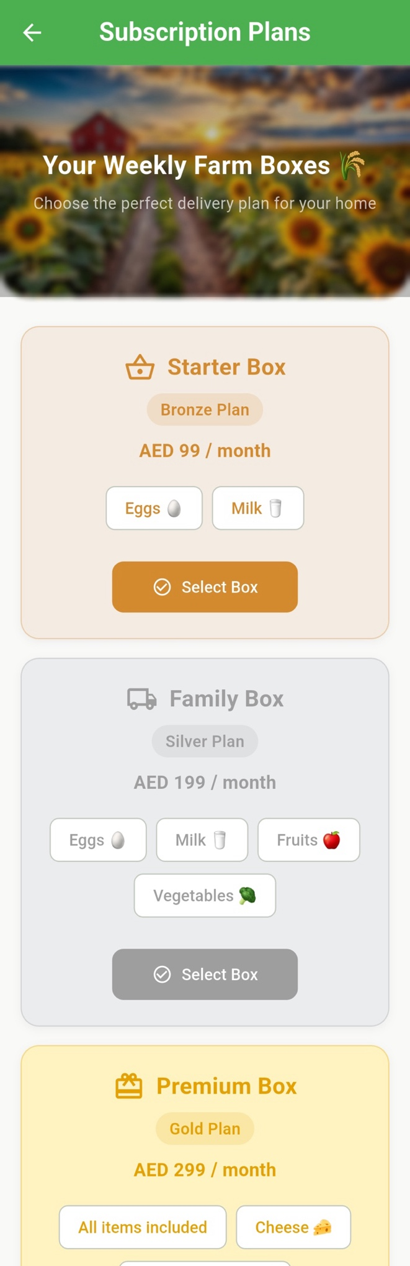
This screen shows the different subscription plans and lets users choose the one that suits them best.

Community_page
This screen is the main Events page. It shows all upcoming farm events, such as Family Farm Day, the Organic Cheese Workshop, and the Harvest Festival. Each event includes its date and a short description. Fact or tip cards appear on the right, and every event has a “Join Event” button.
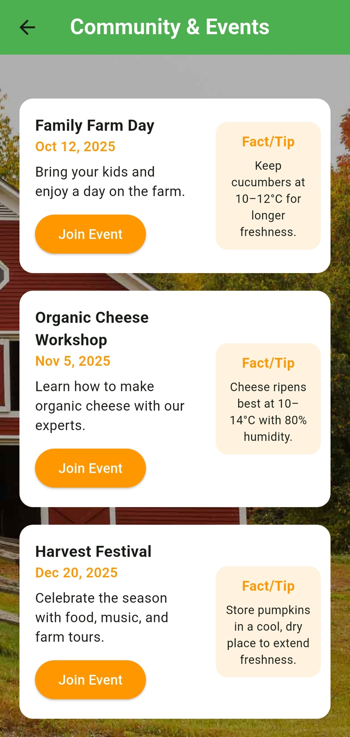

Education_page
This screen shares farming tips, educational articles, and content about sustainability to help users learn more.
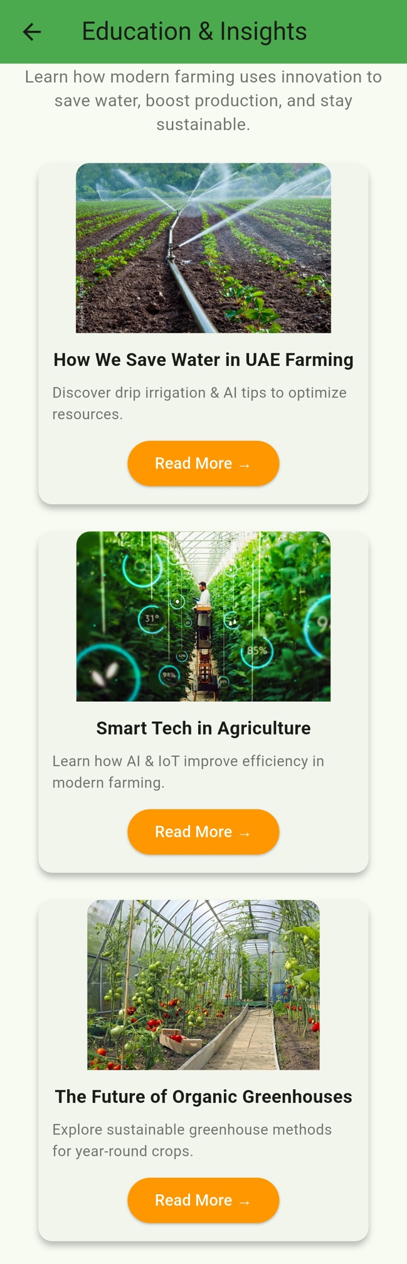

Assistant_page
This screen gives the user a chat space where they can ask questions about products, farming, or the app itself. All replies come from the AI assistant.
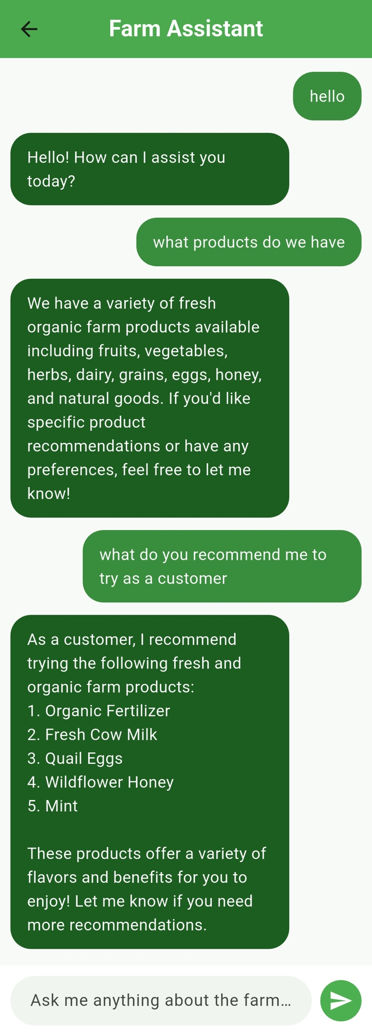

chat_support_page
This screen is the Support & Feedback page. Users can submit a ticket by choosing a complaint type and adding a subject and description. They can also include their email if they want. There is a button to send the ticket, and a “My Previous Tickets” section where users can open and view their past tickets.
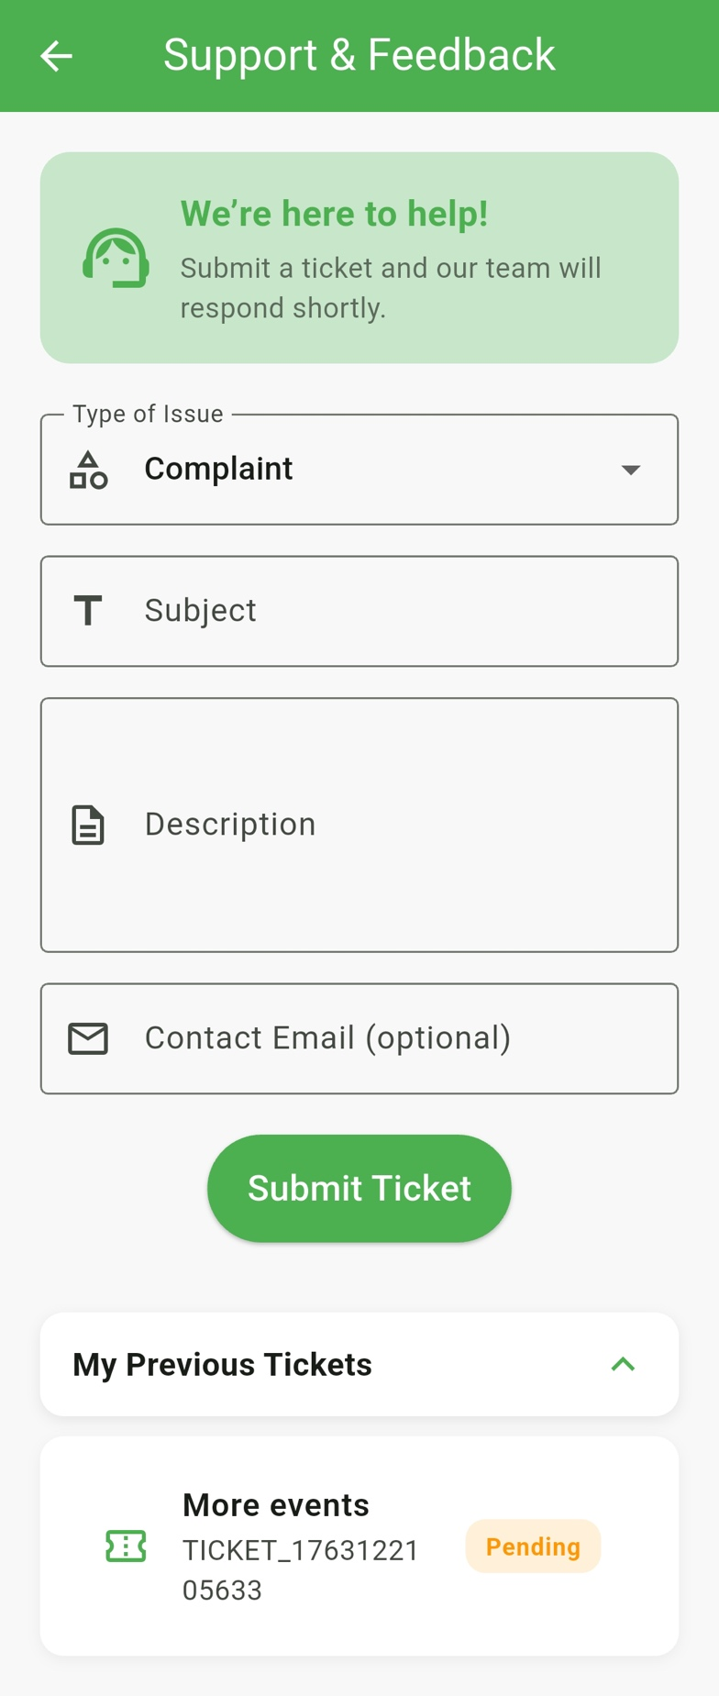

farm_owners_page
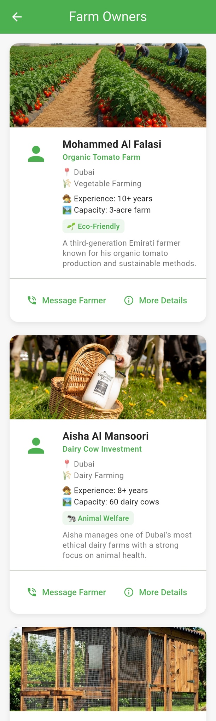
This screen shows information about the farm owners, including their names and basic details.

my_orders section (inside profile_page)
This screen shows all the user’s past orders in a pop-up sheet. It includes the order date and time, the payment method, the total price, and a list of all items in that order.
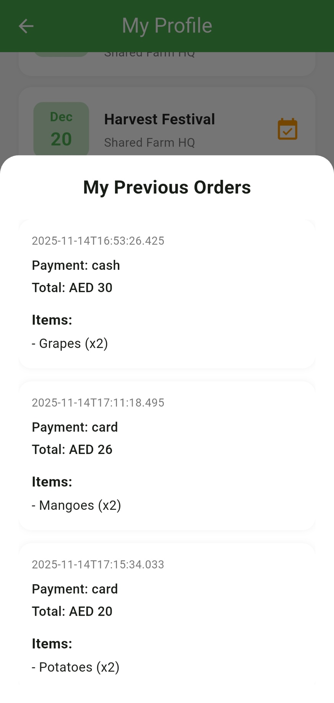

ticket_list (inside profile_page)
This screen shows a pop-up list of the user’s support tickets. Each ticket displays its Ticket ID and current status.
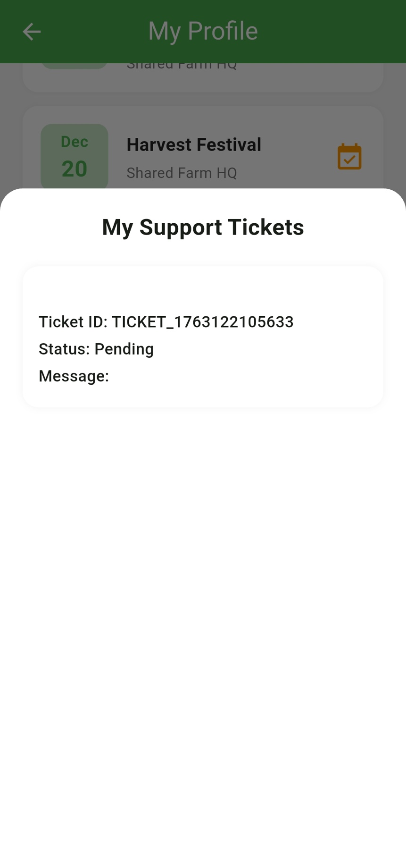

Shared Farm Database Architecture
The Shared Farm app uses Firebase Realtime Database because it updates data instantly, which is important for things like sending tickets, creating orders, tracking deliveries, and loading products. The database stores everything in a light JSON format, which fits the app’s simple data structure. It also works offline and syncs automatically when the user gets their connection back. RTDB connects easily with Flutter using streams and secure login, which saves development time and helps the app run smoothly and reliably for all users.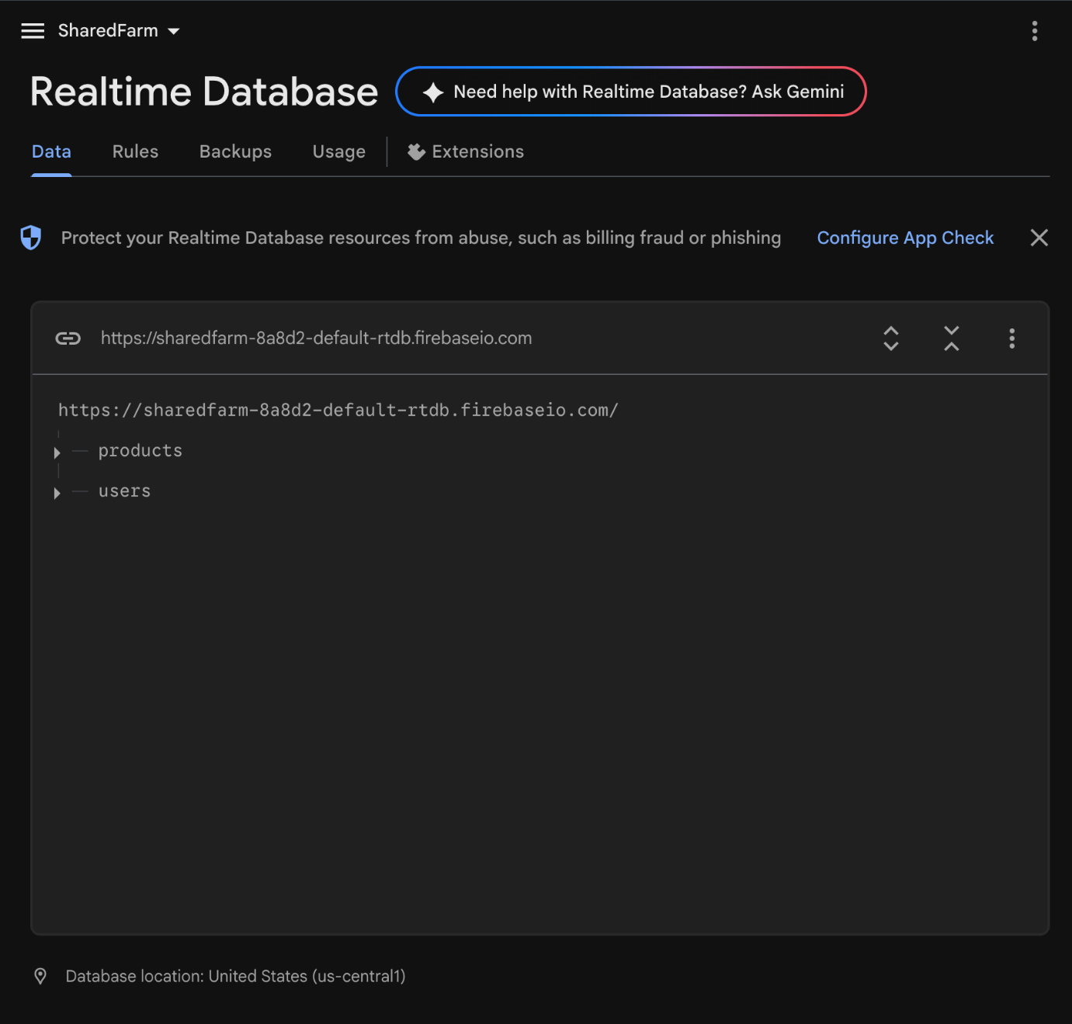

Shared Farm Database Structure
The Shared Farm app uses two main Firebase Realtime Database nodes: products/ and users/. These sections hold all the important app data and support the main screens and features..

1. Products
This node stores the full product catalog shown in the app. Each product includes details like category, name, description, imageUrl, price, and weight. There are 55 products in total, covering fruits, vegetables, dairy, eggs, honey, herbs, grains, natural items, and baked goods.
This data powers the Product Catalog screen and also helps the AI Assistant give product recommendations.
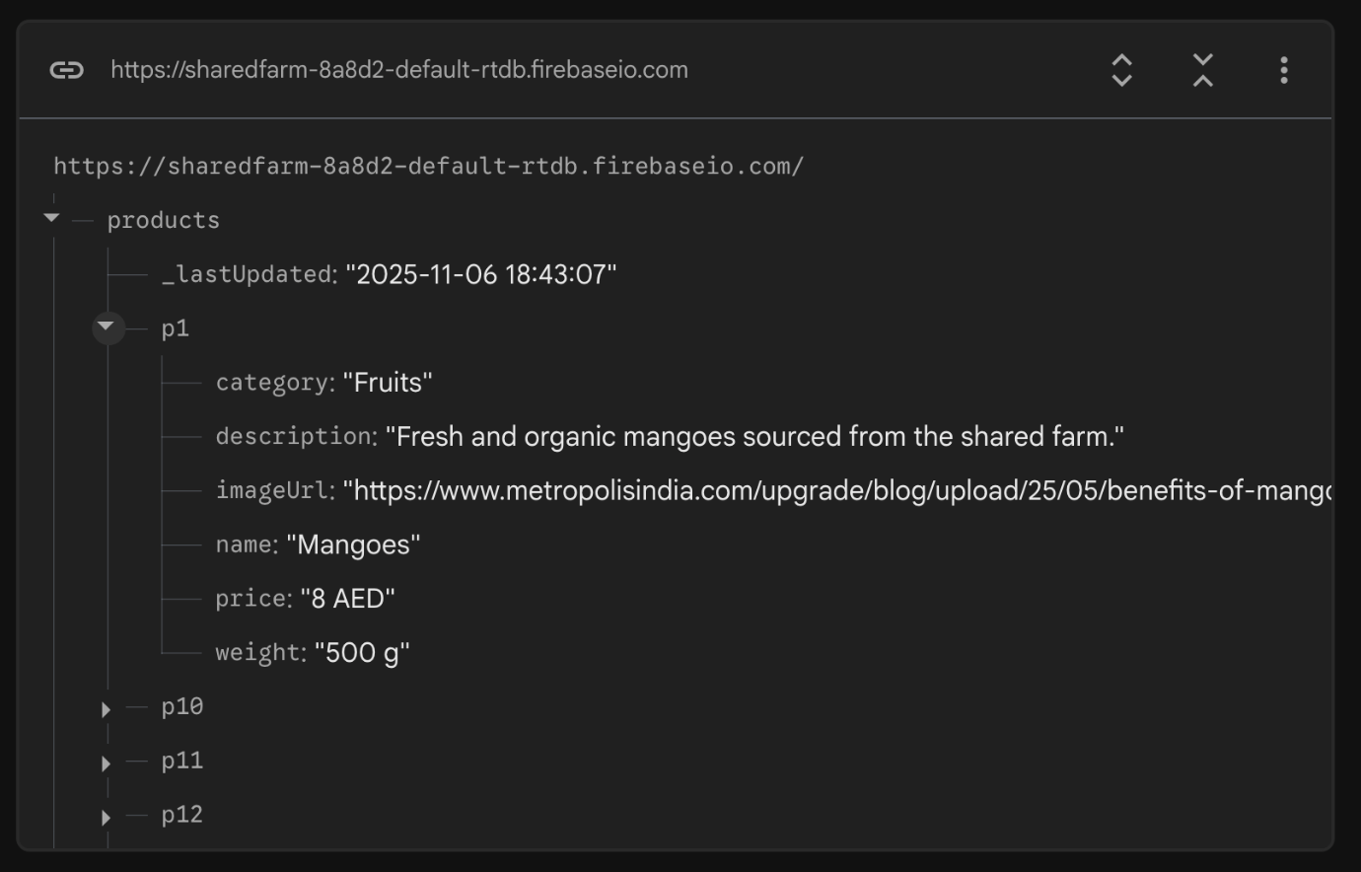

2. Users
This node stores all user accounts and their activity in the app.
It includes basic user details such as name, email, phone, address, birthDate, role, and createdAt.
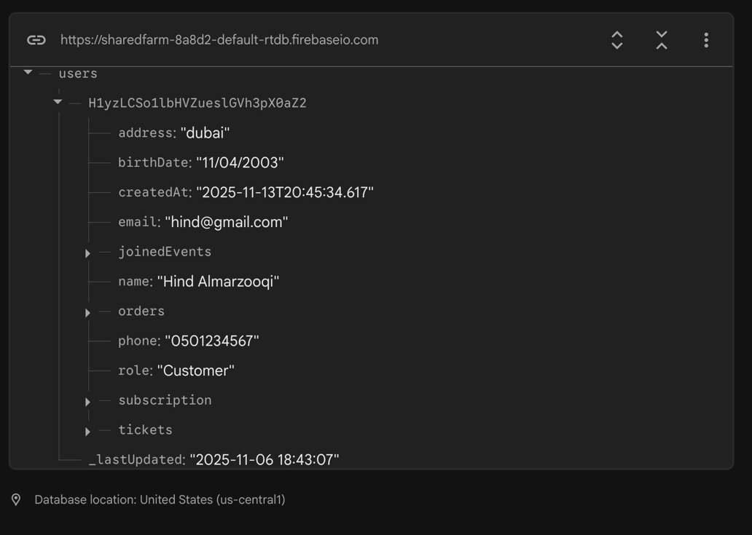

joinedEvents
This section saves every event the user joins. Each event includes the title, date, time, location, description, a farming tip, and the joinedAt timestamp.
Examples of these events are the Organic Cheese Workshop, Family Farm Day, and the Harvest Festival.
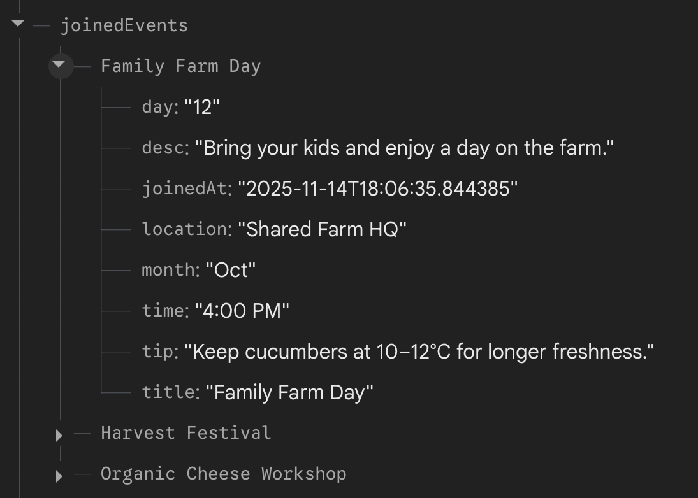

subscription
This section stores the user’s subscription details. It includes their plan (like the Silver Plan), the box type they chose, the price, and the time it was selected.
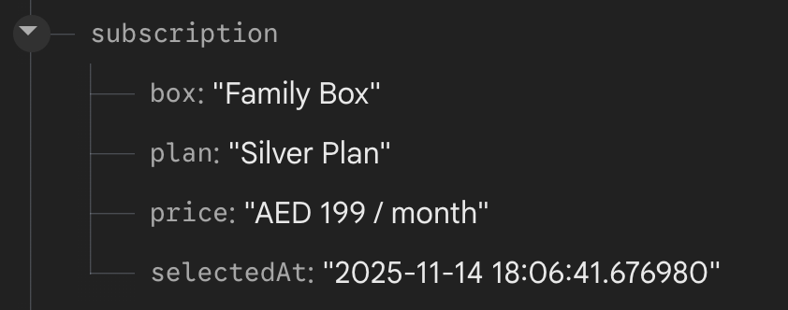

tickets
This section stores all the support tickets that users create through the Support & Feedback page. Each ticket includes the ticketId, subject, description, type, email, submittedAt time, and its status.
These tickets are shown in the My Tickets modal.
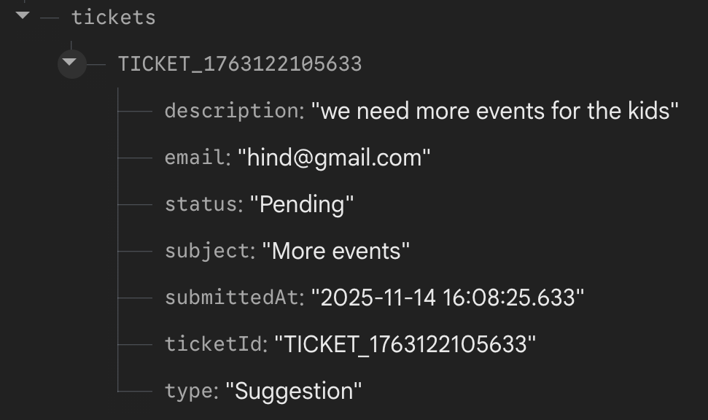

orders
Each order stores the list of items (with name, price, quantity, and image), the payment method, the timestamp, the total amount, and the delivery address.
This information is used in the Order History and Checkout screens.

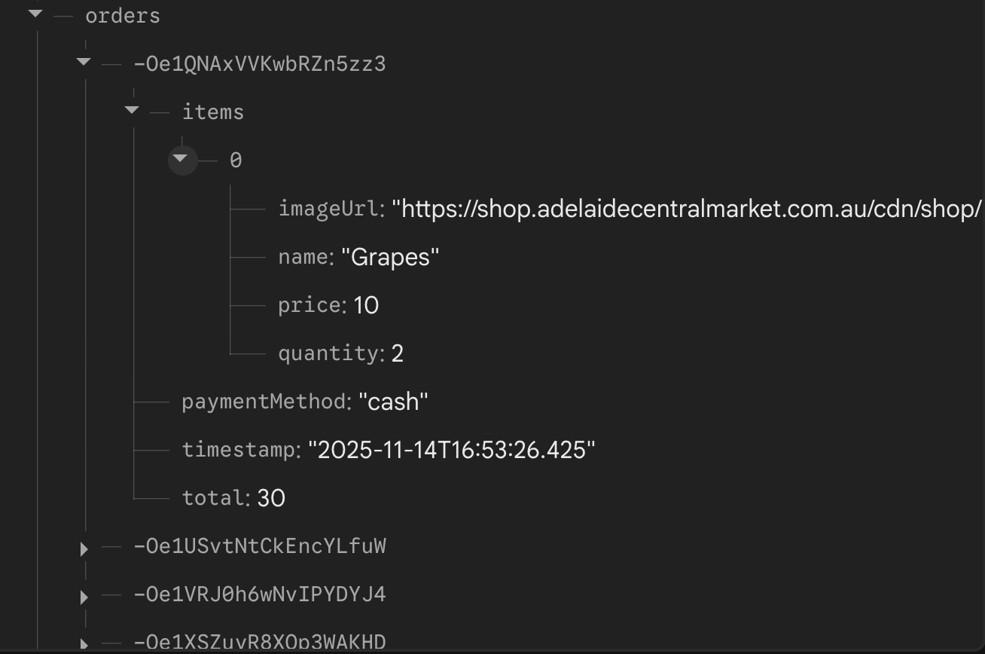

Flutter Framework Overview
The Shared Farm app is built using Flutter, Google’s cross-platform UI framework. Flutter lets the app run on both Android and iOS with one codebase, which keeps the design consistent and speeds up development. Its widget system makes it easy to create clean, modern, and responsive screens, while also keeping the app fast and smooth.
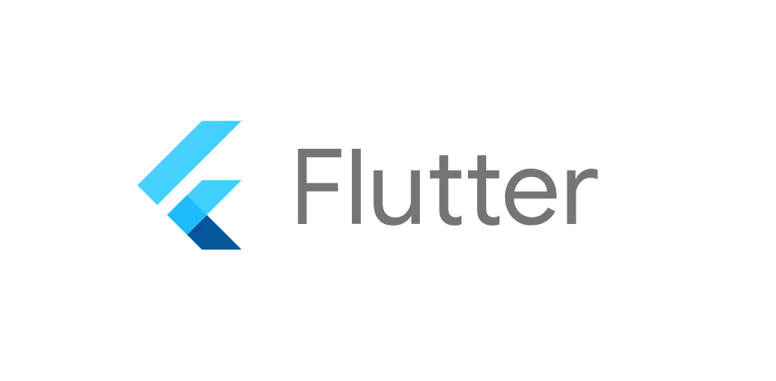

Why Flutter Was Chosen
Flutter was chosen because it offers several key advantages:
1. Cross-Platform Support
Flutter lets us use one codebase for both Android and iOS. This reduces development time and makes sure the app works the same on all devices.
2. Fast UI Development
Flutter’s widget system makes building screens quick and flexible. This is especially useful for pages like product lists, events, tickets, and forms.
3. Strong Firebase Integration
With the FlutterFire SDK, Flutter connects easily to Firebase tools such as Authentication, Realtime Database, data streams (onValue), and secure data handling.
This is very important for the app’s real-time features.

Development Tools Used
The Shared Farm app was built using Visual Studio Code (VS Code) as the main code editor. VS Code was chosen because it runs fast, has great Flutter extensions, includes built-in debugging tools, and works smoothly with Firebase.
For testing the iOS version, the team used the Xcode iOS Simulator. This made it easy to test layouts, screen navigation, and real-time database updates on virtual iPhone devices without needing a real phone.
Together, VS Code and the Xcode Simulator created an efficient and flexible setup for developing and testing the app on both Android and iOS.
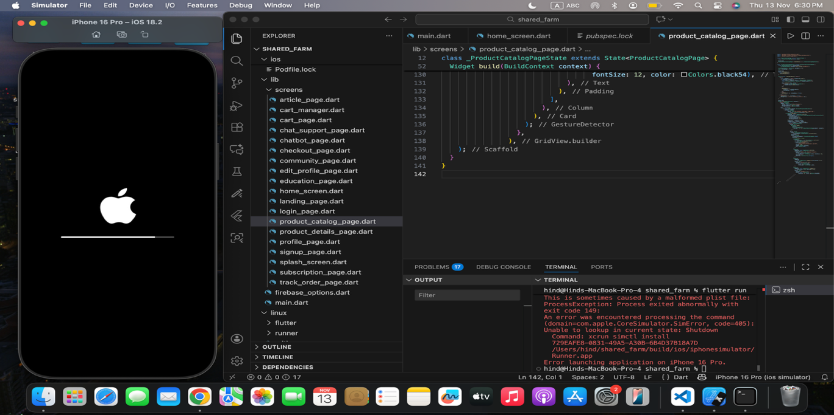

Flutter Use Cases Implemented

1. Signup & Login System
Flutter works directly with Firebase Authentication to create new accounts and handle secure logins. The UI checks the user’s input, sends the data to Firebase, and then takes the user to the dashboard once they are successfully logged in. Flutter widgets are used to manage form validation and show error messages when needed.

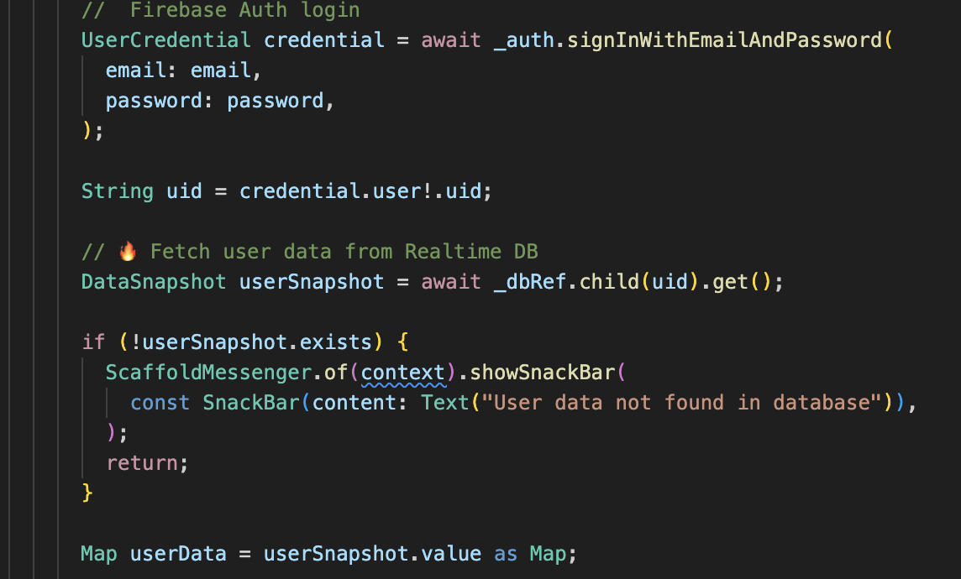
Code Snippet — Firebase Login

Code Snippet — Firebase Signup
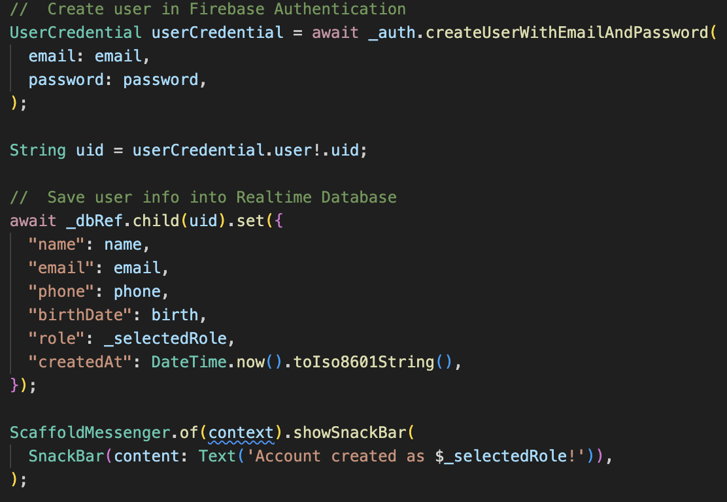

2. Add to Cart & Checkout
Flutter works with Firebase Realtime Database to load products, add items to the cart, update quantities, and submit the final order. The checkout page calculates the totals, saves the order under the user’s profile in Firebase, and then shows a confirmation message. All real-time reading and writing are done using asynchronous Firebase calls.

Code Snippet — Fetch Products From Database
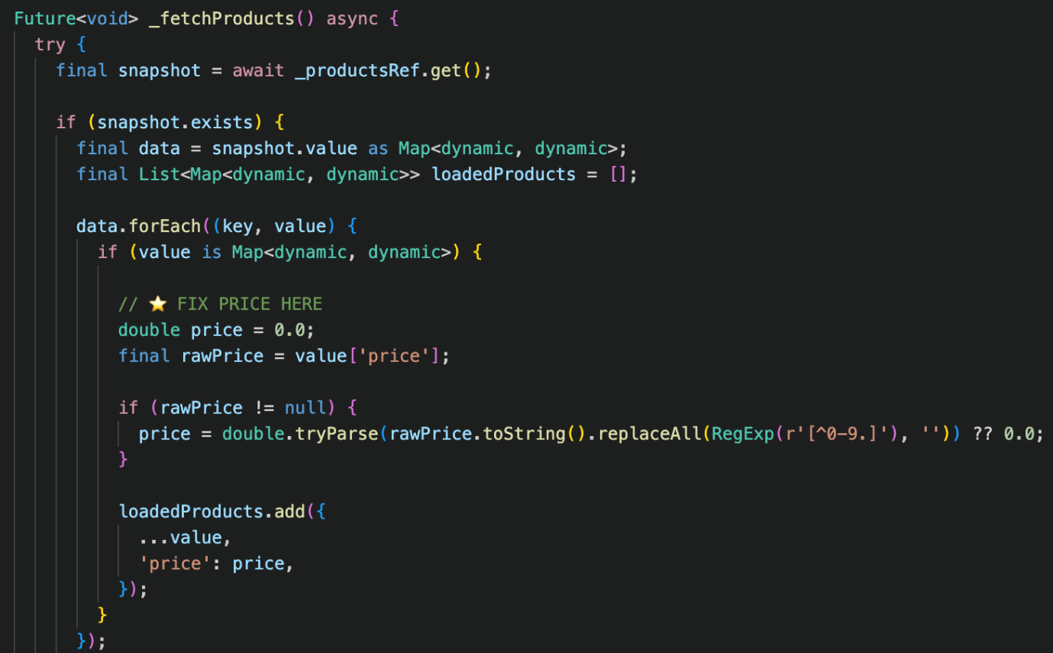

Code Snippet — Add Item to Cart
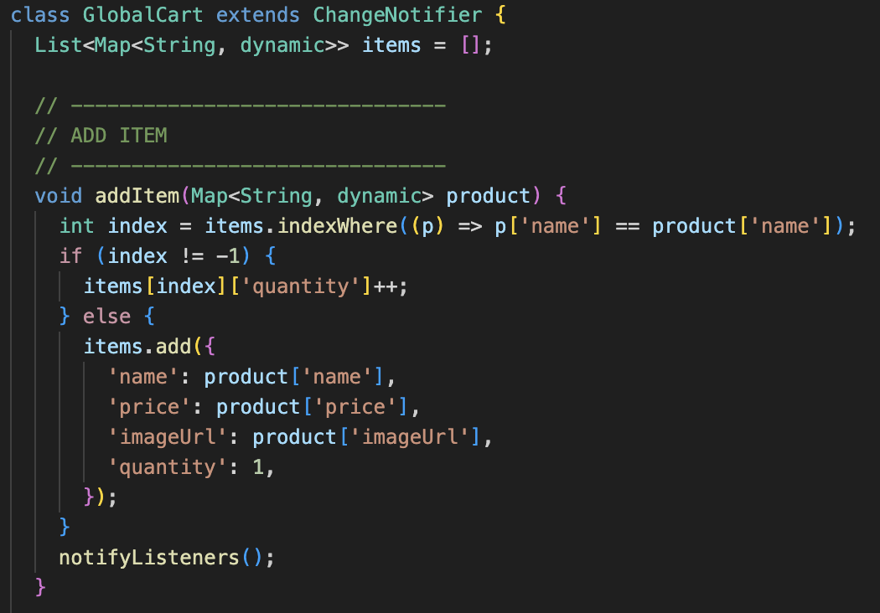

Code Snippet — Submit Order
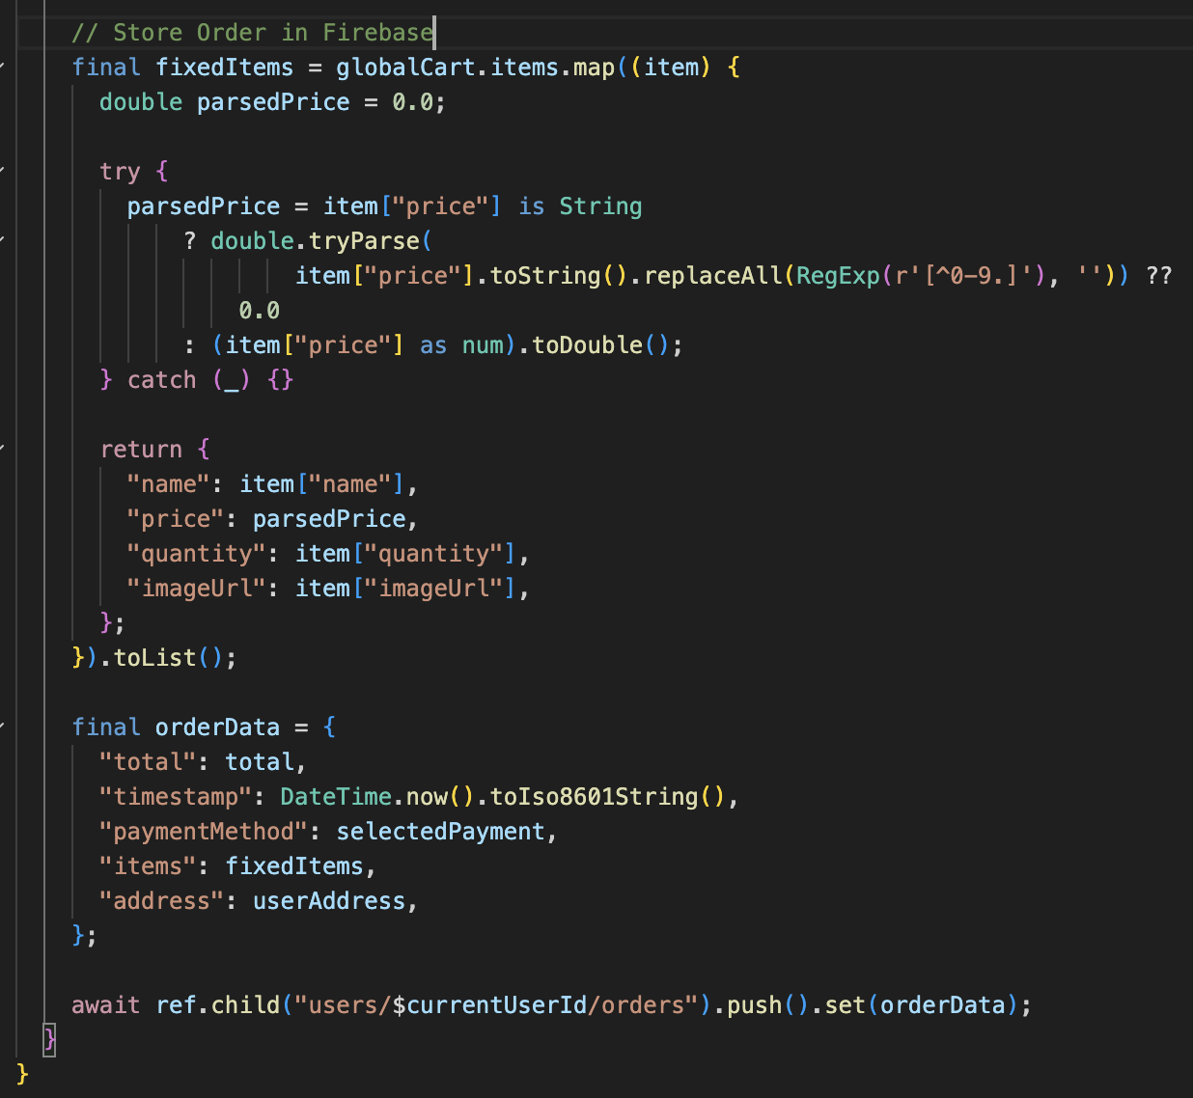

3. AI Assistant

The app includes an AI assistant that uses the OpenAI API. Flutter manages the user’s text input, sends the message to the backend, and shows the reply in a chat-style layout. The assistant also uses Firebase product data so it can give accurate suggestions and helpful answers. The chat screen updates automatically as the conversation continues.

Code Snippet — 1. Firebase Data Fetch (User + Products)
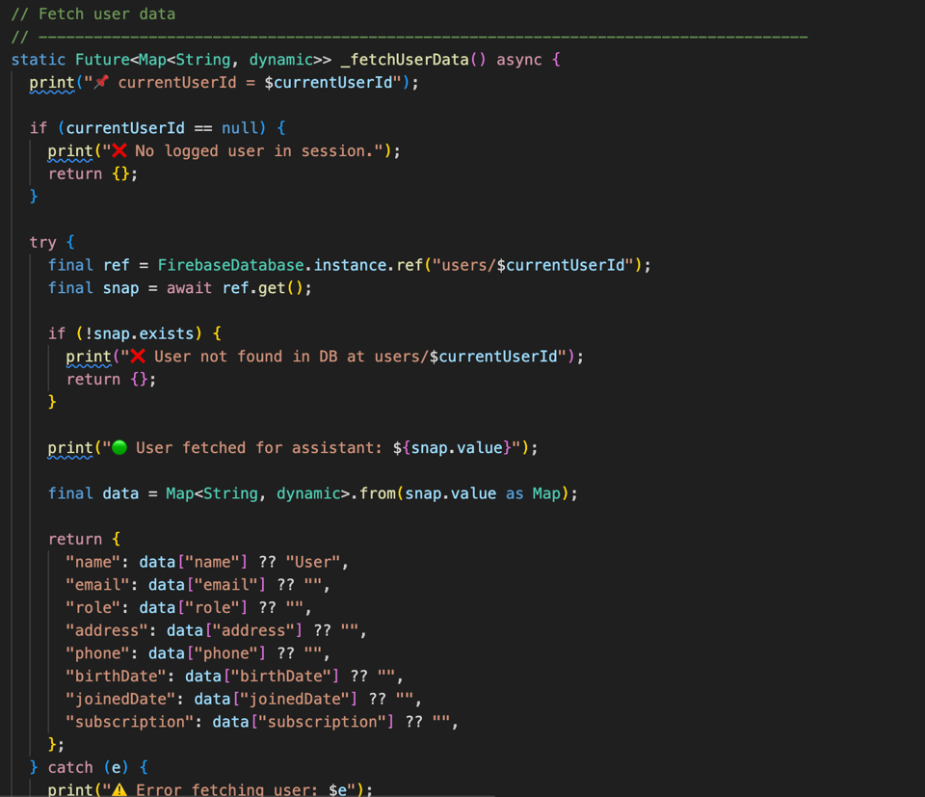

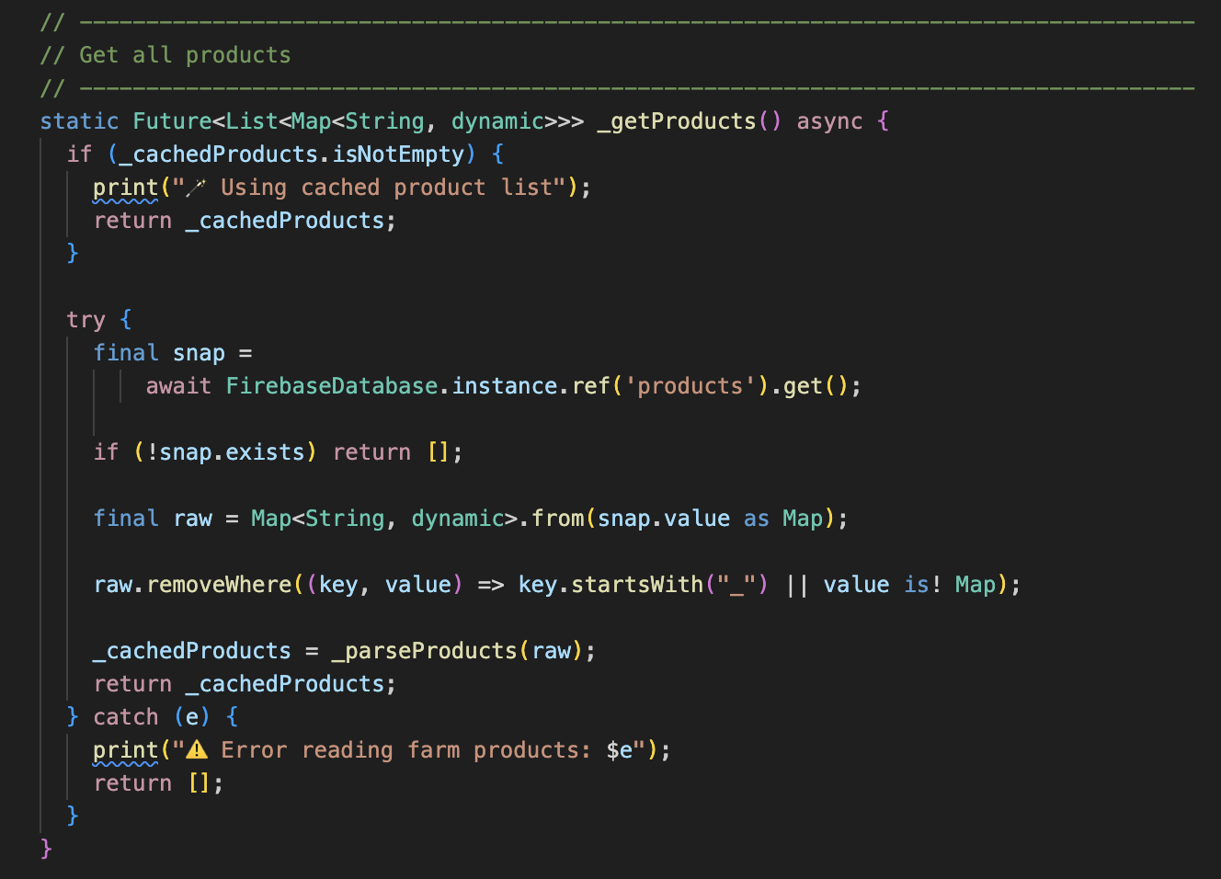

Code Snippet — 2. The Prompt Construction

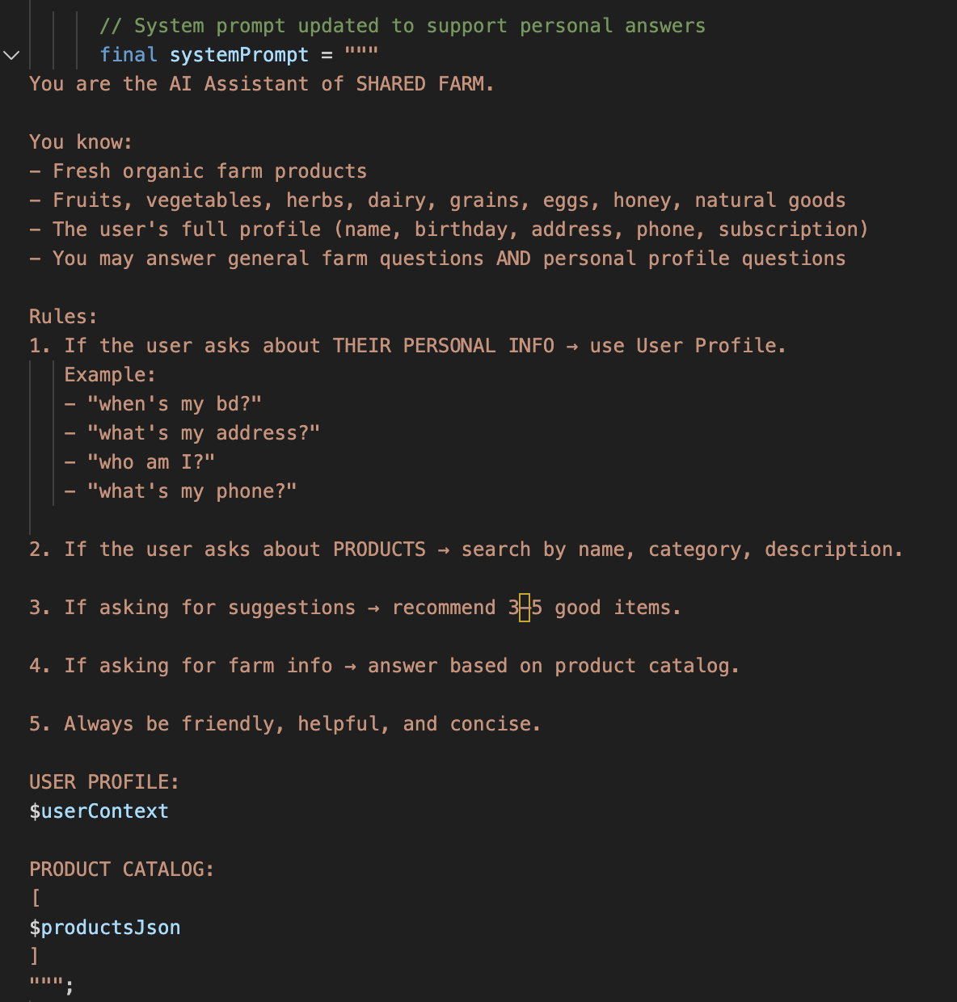

Code Snippet — 3. Sending Request to OpenAI
